

Practices for Secure Software Report

Table of Contents
Practices for Secure Software Report 1
Document Revision History 3
Client 3
Instructions 3
Developer 4
1. Algorithm Cipher 4
2. Certificate Generation 5
3. Deploy Cipher 6
4. Secure Communications 6
5. Secondary Testing 7
6. Functional Testing 9
7. Summary 10
8. Industry Standard Best Practices 10
References 12

Document Revision History

Version | Date | Author | Comments
1.0 | 10/13/2026 | Jacobsin Enriquez | Initial report: SHA-256 checksum, HTTPS, dependency-check, and code review

Client



Instructions

Submit this completed practices for secure software report. Replace the bracketed text with the relevant information. You must document your process for writing secure communications and refactoring code that complies with software security testing protocols.

- Respond to the steps outlined below and include your findings.
- Respond using your own words. You may also choose to include images or supporting materials. If you include them, make certain to insert them in all the relevant locations in the document.
- Refer to the Project Two Guidelines and Rubric for more detailed instructions about each section of the template.

Developer
Jacobsin Enriquez

Algorithm Cipher

For Artemis Financial’s file verification requirement, I recommend the SHA-256 cryptographic hash algorithm to generate the checksum. Because Artemis Financial also stores and transfers sensitive financial data, I recommend AES-256 in Galois/Counter Mode (GCM) for protecting that data and TLS 1.2 or higher with an RSA 2048-bit certificate for every connection to the web application. Each choice addresses a different threat: SHA-256 detects tampering, AES protects confidentiality, and TLS protects data in transit.
- Overview: SHA-256 is part of the SHA-2 family defined in FIPS 180-4 (National Institute of Standards and Technology [NIST], 2015). It converts input of any length into a fixed-length digest. The same input always produces the same digest, while even a one-character change produces a completely different one, and the digest cannot be reversed to recover the original data. A checksum works like a torque-seal mark on a critical bolt: it does not stop anyone from turning the bolt, but it shows immediately if someone did. Because a hash provides integrity rather than secrecy, I pair it with AES, a symmetric block cipher standardized in FIPS 197 (NIST, 2023), and with TLS for the connection itself (Rescorla, 2018).
- Hash Functions and Bit Levels: SHA-256 produces a 256-bit digest, displayed as 64 hexadecimal characters (NIST, 2015), and provides 128 bits of collision resistance, which is beyond the reach of practical attacks (Barker, 2020). Older algorithms are no longer acceptable for security use: MD5 (128-bit) has known collisions, and researchers produced the first practical collision for SHA-1 (160-bit) in 2017 (Stevens et al., 2017). SHA-384 and SHA-512 remain available if Artemis Financial wants a larger security margin (NIST, 2015). For AES, the 256-bit key size offers the highest strength of the three standard key lengths (128, 192, and 256 bits) while still encrypting data in 128-bit blocks (NIST, 2023). Since a plain checksum does not prove who sent the data, I recommend HMAC-SHA256, which mixes a secret key into the hash, for any transfer where authenticity matters (Barker, 2020).
- Random Numbers: Encryption keys, initialization vectors, and nonces must come from a cryptographically secure random number generator. In Java, that is SecureRandom, not java.util.Random, whose output is predictable (Oracle, n.d.). With AES-GCM, each encryption must also use a fresh initialization vector.
- Symmetric vs. Asymmetric Keys: Symmetric algorithms such as AES use one shared secret key to encrypt and decrypt, which makes them fast enough for bulk data but requires that the key be distributed and stored securely. Asymmetric algorithms such as RSA use a public and private key pair; the public key can be shared openly, but the operations are much slower (Barker, 2020). TLS combines both approaches: the server’s certificate and asymmetric key exchange authenticate the server and establish session keys, and a fast symmetric cipher then protects the traffic (Rescorla, 2018).
- History and Current State: Encryption standards have been replaced as computing power grew and weaknesses were found. NIST published AES in 2001, and it remains the standard symmetric cipher today (NIST, 2023). Hash algorithms followed the same pattern: MD5 and then SHA-1 were retired from security use, with SHA-1 abandoned after the first practical collision in 2017 (Stevens et al., 2017). On the transport side, the older SSL protocols evolved into TLS, and TLS 1.3, published in 2018, removed legacy ciphers and requires forward secrecy (Rescorla, 2018). Today, AES, the SHA-2 family, and RSA or elliptic-curve keys of adequate size form the current baseline that NIST recommends for protecting sensitive data (Barker, 2020).

Certificate Generation
Insert a screenshot below of the CER file.

I generated a self-signed certificate with the Java keytool utility in Eclipse, stored it in a PKCS12 keystore inside the project’s resources folder, and exported it as a CER file:
keytool -genkeypair -alias artemisfinancial -keyalg RSA -keysize 2048
-sigalg SHA256withRSA -storetype PKCS12 -keystore keystore.p12 -validity 365
-dname "CN=localhost, OU=Artemis Financial, O=Global Rain, L=Manchester, ST=NH, C=US"
-ext SAN=dns:localhost,ip:127.0.0.1
keytool -exportcert -alias artemisfinancial -keystore keystore.p12 -file artemisfinancial.cer -rfc

- Key and Signature: RSA 2048-bit key pair signed with SHA256withRSA, valid for 365 days.
- Subject Alternative Name: localhost and 127.0.0.1 were added so modern browsers match the certificate to the local host name.
- Keystore Format: I used the PKCS12 keystore format instead of the older Java-specific JKS format.
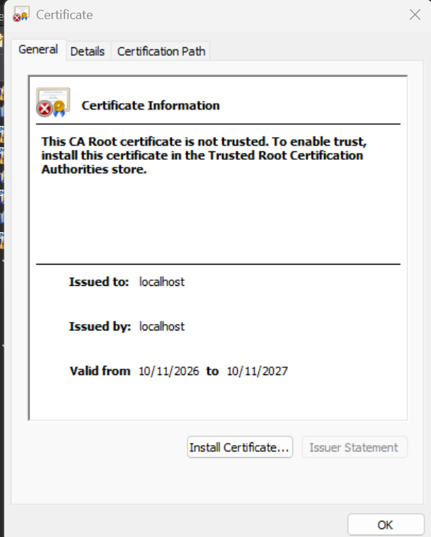
Self-signed artemisfinancial.cer certificate issued to and by localhost, valid 10/11/2026 to 10/11/2027

Deploy Cipher
Insert a screenshot below of the checksum verification.

I refactored SslServerApplication.java to add a ChecksumController with a GET /hash route. The route computes the SHA-256 digest of a static data string using Java’s built-in MessageDigest class (Oracle, n.d.) and returns the data, the algorithm name, and the checksum as plain text.
- Data String: Hello World Check Sum! - Jacobsin Enriquez - CS305-ArtemisFinancial-7f3a9c21
- Checksum: c8dfef9923f3f7db896d0e8ce2e6cd3b4666269a9b9e2fa83051f13e2a60c09a
- Verification: I confirmed the checksum independently with a separate SHA-256 tool, and it matches the value returned by the application.
- Unit Tests: ChecksumControllerTests verifies the known checksum, confirms that different inputs produce different checksums, and confirms that the output is 64 hexadecimal characters. All three tests pass.
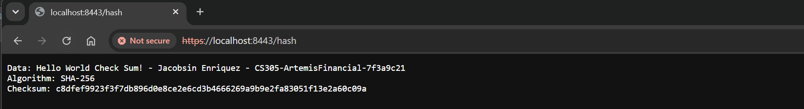
Checksum verification at https://localhost:8443/hash showing my name in the data string and the SHA-256 checksum

Secure Communications
Insert a screenshot below of the web browser that shows a secure webpage.

I refactored application.properties to convert the application from HTTP to HTTPS:
server.port=8443
server.ssl.enabled=true
server.ssl.key-alias=artemisfinancial
server.ssl.key-store=classpath:keystore.p12
server.ssl.key-store-type=PKCS12
server.ssl.key-store-password=********
server.ssl.enabled-protocols=TLSv1.2

- HTTPS Only: The application now listens only on port 8443 over TLS, so the plain-HTTP port is never opened.
- Protocol Version: I restricted the server to TLS 1.2, which blocks the older TLS 1.0 and 1.1 protocols. Because the project targets Java 8, this setting keeps it compatible with older Java 8 runtimes that do not offer TLS 1.3. Since the application ran on a Java 21 runtime during testing, I recommend also enabling TLS 1.3 when Artemis Financial standardizes on a newer Java version (Rescorla, 2018).
- Browser Warning: The browser marks the page as not secure because the certificate is self-signed and does not chain to a trusted certificate authority (Cooper et al., 2008). The connection is still encrypted; in production, Artemis Financial should use a CA-issued certificate.
Secure HTTPS connection to https://localhost:8443/hash (the warning is expected for a self-signed certificate)

Secondary Testing
Insert screenshots below of the refactored code executed without errors and the dependency-check report.

I configured the OWASP Dependency-Check Maven plugin (version 12.1.0) in pom.xml and ran it with mvn verify to scan the project’s libraries against the National Vulnerability Database (OWASP Foundation, n.d.). The rubric asks me to focus on the code I added during refactoring:
- Code I Added: The checksum route, the HTTPS configuration, and the unit tests use only the Java standard library (java.security.MessageDigest) and Spring annotations that were already in the project. I did not add any new third-party dependencies, so my refactoring did not introduce any new vulnerable libraries.
- Scan Results: The scan examined 49 dependencies (31 unique) and flagged 16 libraries with 295 known vulnerabilities, including spring-core, spring-web, tomcat-embed-core, jackson-databind, and snakeyaml. Several are rated critical, and the report marks some as known exploited vulnerabilities. Every flagged library is inherited from the original Spring Boot 2.2.4 framework; none came from the code I added. All four unit tests passed during the same build, which completed with BUILD SUCCESS.
- Tool Configuration: I supplied a free NVD API key at run time rather than storing it in pom.xml, and I disabled the optional Sonatype OSS Index analyzer because it now requires separate credentials. The NVD remained the vulnerability source for the scan.
- Remediation: Because the vulnerabilities live in the inherited framework, the fix is to upgrade the Spring Boot parent version in pom.xml to a currently supported release, which pulls in patched versions of Spring, Tomcat, Jackson, and SnakeYAML, and then re-run the scan and tests until no new vulnerabilities appear.
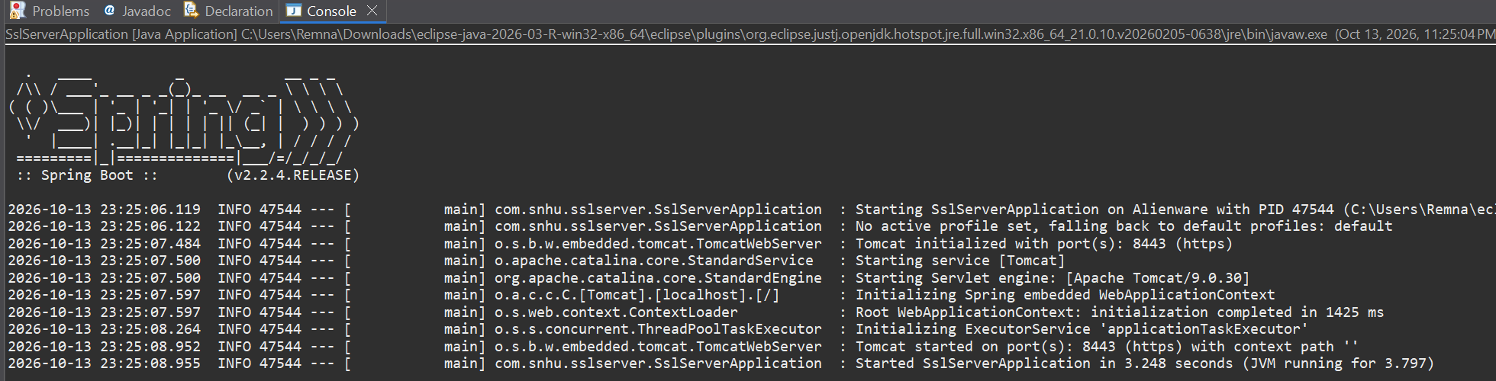
Refactored application running without errors: Tomcat started on port 8443 (https)
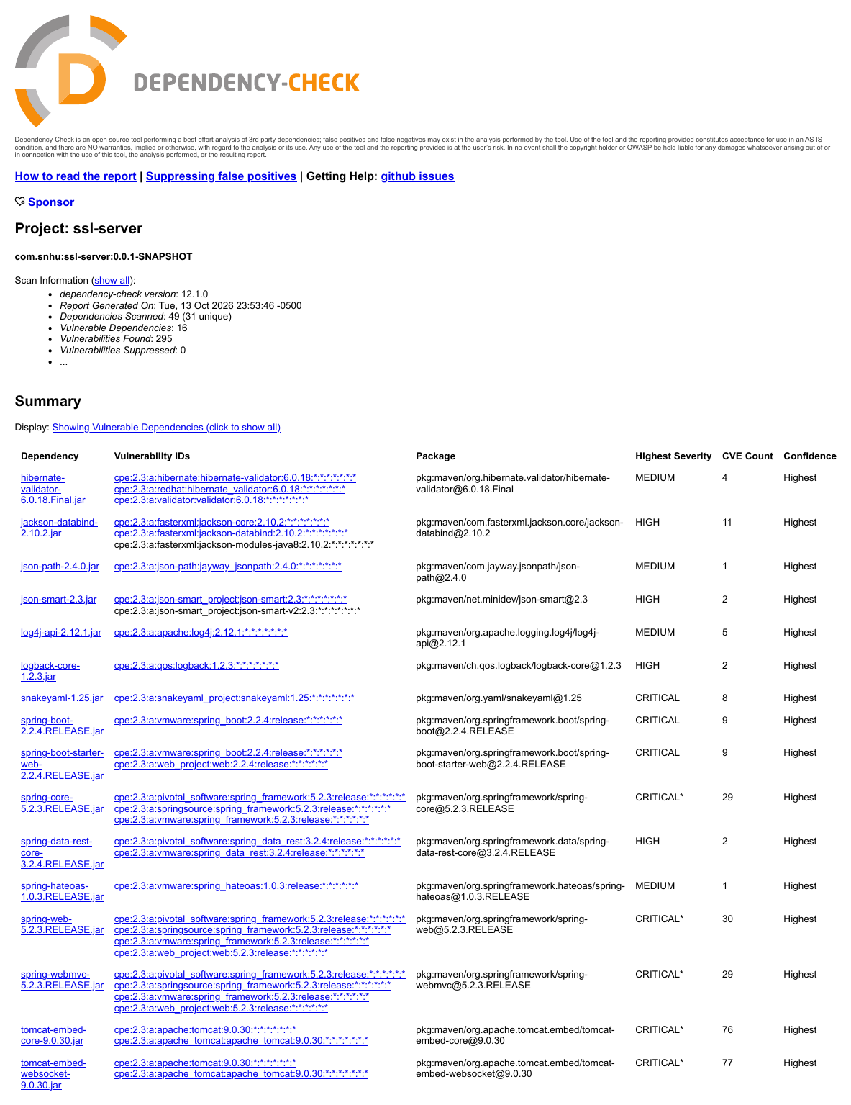
OWASP Dependency-Check report summary for ssl-server: 49 dependencies scanned, 16 vulnerable, 295 vulnerabilities found
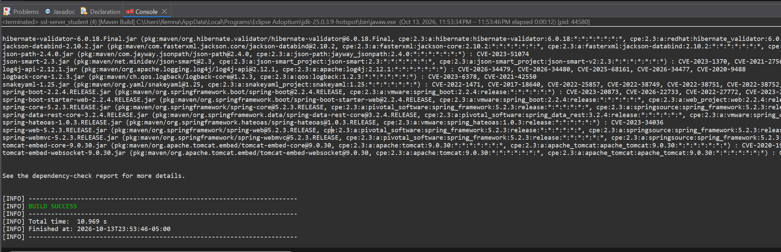
Dependency-check build output: flagged inherited libraries and BUILD SUCCESS

Functional Testing
Insert a screenshot below of the refactored code executed without errors.

I manually reviewed the refactored code for syntactical, logical, and security issues:
- Syntax: The project compiles and the application starts without errors.
- Logic: The checksum is calculated over the UTF-8 bytes of the data string, and the output matches an independent SHA-256 calculation.
- Input Handling: The /hash route accepts no user input, so there is no injection surface, and it returns text/plain, which prevents HTML or script injection.
- Error Handling: If the algorithm is unavailable, the route returns a generic HTTP 500 message without a stack trace or internal details.
- Secrets: The keystore password is stored in plain text in application.properties. This is acceptable for a classroom certificate, but in production the password should come from an environment variable or secrets vault and never be committed to source control.
- Authentication: The endpoints are currently open. Spring Security should be added before any real client data is exposed.
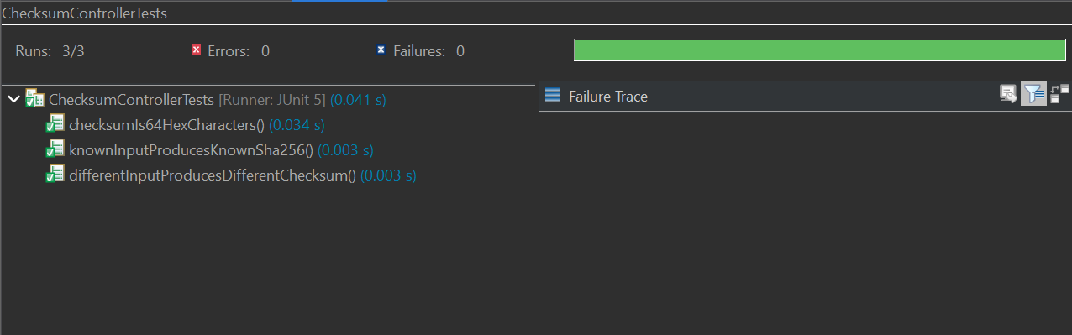
ChecksumControllerTests: 3 of 3 unit tests passed with no errors or failures
Refactored application started without errors after the code review

Summary

I refactored the code by working through the course’s vulnerability assessment process flow diagram and focusing on the areas this change affects:
- Cryptography: Added a SHA-256 checksum, an RSA 2048-bit certificate, and a PKCS12 keystore, and avoided broken algorithms such as MD5 and SHA-1.
- Client/Server: Converted the application from HTTP to HTTPS on port 8443 with TLS 1.2 enforced.
- Input Validation: Designed the new route to accept no user input, which removes the injection surface entirely.
- Code Error: Returned a generic error message on failure so the application does not leak internal details.
- Code Quality: Added unit tests, kept the code in standard library calls, and scanned dependencies with an automated tool.
My process for adding layers of security worked from the outside in. First, I identified what needed protection: client data in transit and the integrity of transferred files. Then I added transport encryption with TLS and a certificate, an integrity control with the SHA-256 checksum, and automated checks with unit tests and dependency scanning. Finally, I reviewed the code manually and recorded the remaining follow-up items: the plain-text keystore password, the missing authentication, and the older framework version. Like lockout/tagout on industrial equipment, each layer is designed to hold even if another one fails.
Code Files Attached: SslServerApplication.java (checksum route), application.properties (HTTPS settings), keystore.p12 and artemisfinancial.cer (certificate), ChecksumControllerTests.java (unit tests), and pom.xml (dependency-check plugin), all included in the CS 305 Project Two Refactored Code Base ZIP file.

Industry Standard Best Practices

I applied industry standard best practices for secure coding, guided by the OWASP Secure Coding Practices (OWASP Foundation, 2010), to maintain the application’s existing security while adding new features:
- Vetted Cryptography: Used Java’s standard MessageDigest and keytool instead of custom algorithms, and chose current algorithms and key sizes.
- Secure Communication: Enforced encrypted transport and disabled plain HTTP.
- Small Attack Surface: Accepted no user input on the new route and kept error messages generic.
- Dependency Management: Added no new third-party libraries and scanned the project with OWASP Dependency-Check.
- Testing: Added unit tests so the checksum behavior can be verified and does not regress.
Applying these practices protects Artemis Financial’s overall well-being. In 2024, a data breach in the financial industry cost an average of $6.08 million, 22% higher than the global average (Bonderud, 2024). Preventing vulnerabilities during development is far less expensive than responding to a breach, and secure code protects client trust, supports regulatory compliance for financial data, and reduces rework. It also reflects Global Rain’s principle that security is everyone’s responsibility.

References
Barker, E. (2020). Recommendation for key management: Part 1 – General (NIST Special Publication 800-57 Part 1, Rev. 5). National Institute of Standards and Technology. https://doi.org/10.6028/NIST.SP.800-57pt1r5
Bonderud, D. (2024, August 13). Cost of a data breach 2024: Financial industry. IBM. https://www.ibm.com/think/insights/cost-of-a-data-breach-2024-financial-industry
Cooper, D., Santesson, S., Farrell, S., Boeyen, S., Housley, R., & Polk, W. (2008). Internet X.509 public key infrastructure certificate and certificate revocation list (CRL) profile (RFC 5280). Internet Engineering Task Force. https://doi.org/10.17487/RFC5280
National Institute of Standards and Technology. (2015). Secure hash standard (SHS) (Federal Information Processing Standards Publication 180-4). U.S. Department of Commerce. https://doi.org/10.6028/NIST.FIPS.180-4
National Institute of Standards and Technology. (2023). Advanced Encryption Standard (AES) (Federal Information Processing Standards Publication 197, Upd. 1). U.S. Department of Commerce. https://doi.org/10.6028/NIST.FIPS.197-upd1
Oracle. (n.d.). Java Cryptography Architecture (JCA) reference guide. https://docs.oracle.com/javase/8/docs/technotes/guides/security/crypto/CryptoSpec.html
OWASP Foundation. (n.d.). OWASP Dependency-Check. https://owasp.org/www-project-dependency-check/
OWASP Foundation. (2010). OWASP secure coding practices quick reference guide (Version 2.0). https://owasp.org/www-project-secure-coding-practices-quick-reference-guide/
Rescorla, E. (2018). The Transport Layer Security (TLS) protocol version 1.3 (RFC 8446). Internet Engineering Task Force. https://doi.org/10.17487/RFC8446
Stevens, M., Bursztein, E., Karpman, P., Albertini, A., & Markov, Y. (2017). The first collision for full SHA-1. In J. Katz & H. Shacham (Eds.), Advances in cryptology – CRYPTO 2017 (pp. 570–596). Springer. https://doi.org/10.1007/978-3-319-63688-7_19

